# Search Design

The search page is going to be a mix of guided search, advanced search, and simple search. What this means is that we are going to try to get the best of both worlds. Not so complex as a full, not so visually appealing UCM advanced search. Not as simple as just a free-text, keyword search. We are going to strike a balance so as to achieve maximum functionality and maximum ease of use. This balance is reflected in the following picture.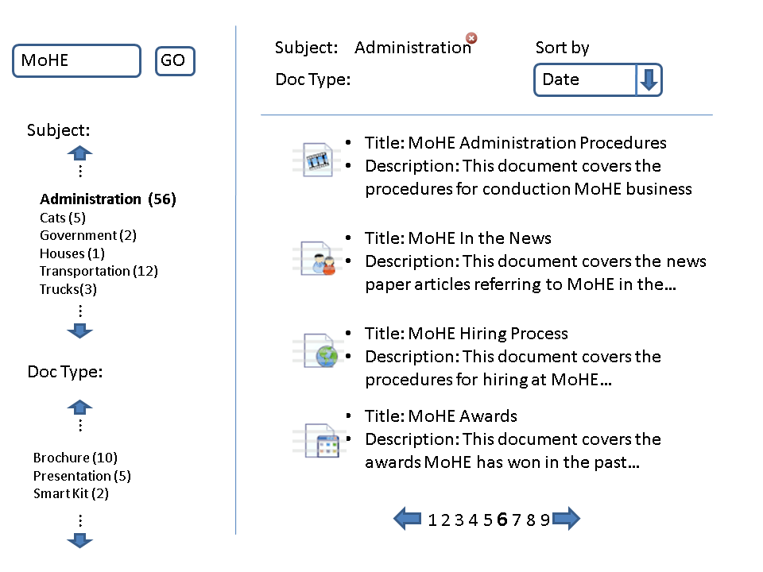

## General Flow

This page will be arrived at whenever a user enters a search term into the search box in the portal and hit search. In the case above the user searched on the term ‘MoHE’.

## Refining Search

The user, after they have conducted a key word search can further refine their search by selecting values from the Subject and Doc Type metadata fields.

## Features of the Search

**Partial Refresh**: Every time a subject or document type is selected, or removed a new search will be conducted against the content server. The whole page will not be reloaded, just the search results.

**Alphabetical Sorting:** The subject and Doc Type options should be sorted alphabetically.

**Option Tallies:** Each option should have a bracketed tally (sum) beside it to show how many documents fall into that option.

**Selected Items Highlighted**: When a user selects an option it should be made visibly clear that they have selected that item. This may be done with bolding, increased font size or some other mechanism.

**Scroll Options**: Since the list of options may be long, there should be a mechanism to scroll through the available options to conserve page real estate.

**Sort By:** There will be a sort by field where the user can choose to sort ascending or descending on the available fields. Date and Title will be the minimal fields.

**Pagination:** There should be a way to handle the pagination so a user can move forward and backwards in their search.

**Search Results:** The search results should contain several important fields such as Title, Description and whatever other fields are deemed required.